Name ___________________________ **Holiday Take Home Exam – Proportions & Ratios**

Please show your work for EVERY question, even the multiple choice. You will not receive credit for a question if there is no work shown.

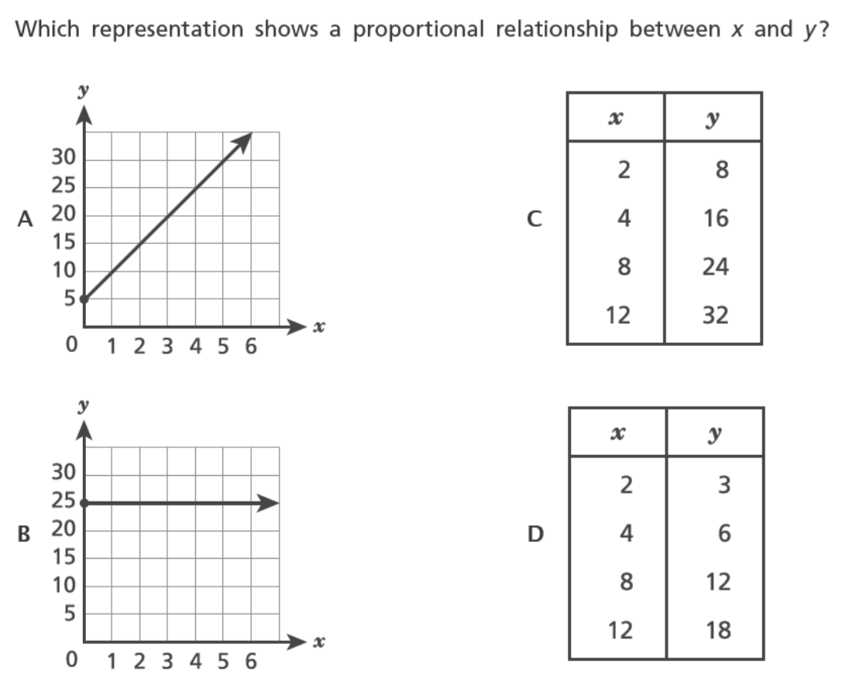1.

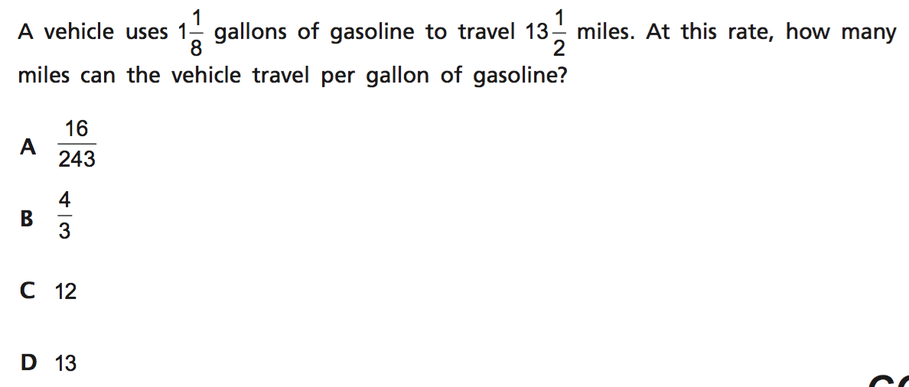2.

3. 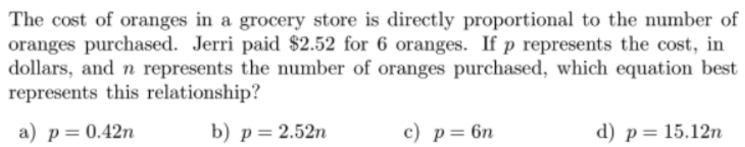

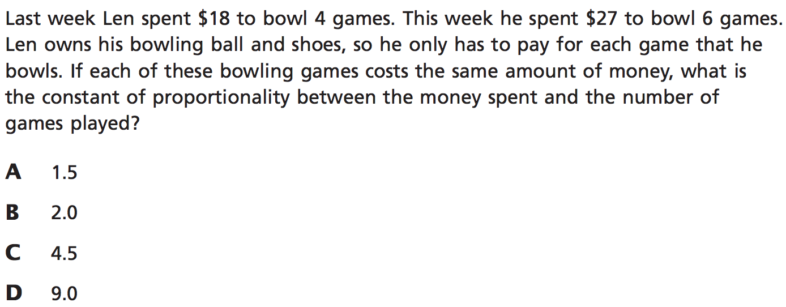4.

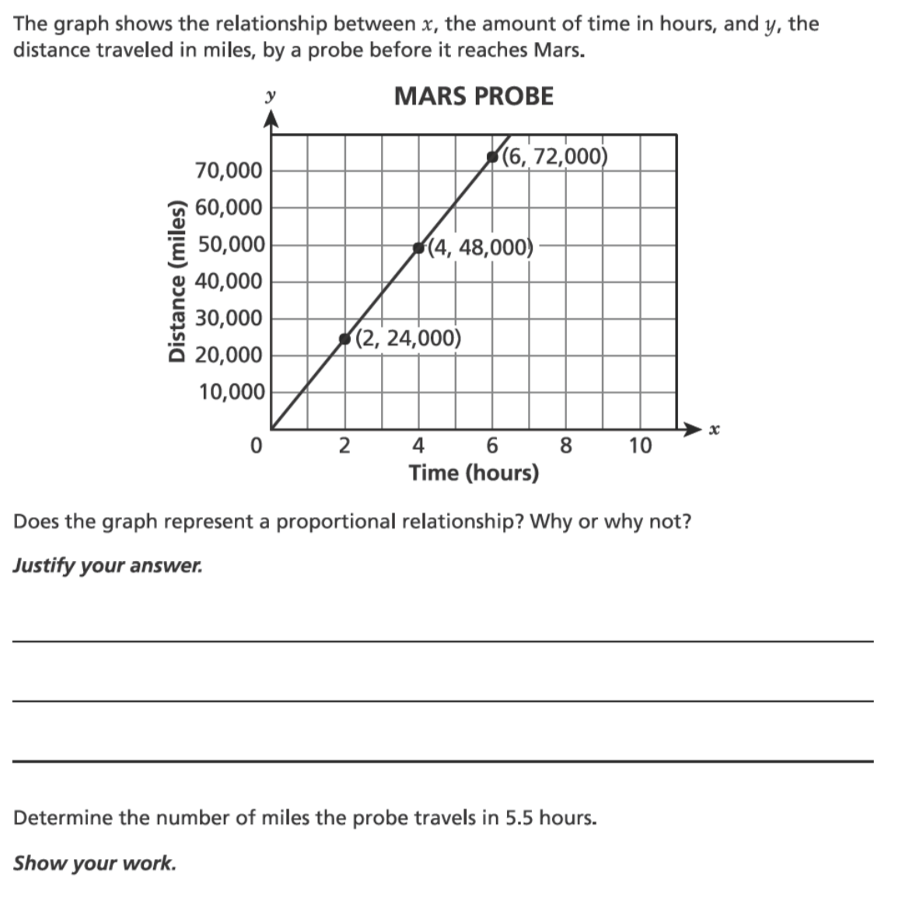5.

6. When a plumber is called, the cost of the service call is $50 for him to show up at your house,

plus an additional $25 per hour. The plumber charged you $162.50 for the service. How many hours did

he spend on fixing your kitchen?

