Name ______________________________________________________________________________________
Unit Two Homework #5
Unit 1: Expressions and Equations | Date Assigned: | Due Date:
Assignments |  | Self-Assessment | Points Earned
- Combining Like Terms  - Complete the problems in the attached assignment. |  | - I did excellent!  - I did well.  - I did okay  - I am having trouble understanding.
- Simplifying Expressions  - Complete the problems in the attached assignment. |  | - I did excellent!  - I did well.  - I did okay  - I am having trouble understanding.
Total

Identify like terms in the expression below. You do not need to simplify the expression.

$4x-7+6y-3+10x-2y$

Simplify the following expressions by combining like terms:

$$3x + 4y - 7x + 2y$$

$$10x + 6 - 5x - 3$$

$-2a-8+7a$

$6x-8+7x-2y+3+8y$

$2.5x-8y+4x+3.5y$

Simplify each expression by using the distributive property:

$$4(3x - 8) =$$

$$-2(7 - 4y) =$$

$$3(-2a + 5) =$$

Simplify by adding or subtracting the expressions:

(3x + 5) - (6x - 9)

(5x + 4) + (3x - 7)

Simplify each expression by using the distributive property and combining like terms:

$3\left(2x-5\right)+6$

$-2\left(6-4y\right)+9y$

$4\left(3x-8\right)+2(7-5x)$

Simplify the following expressions:

$2.5x+x=$

$\frac{1}{2}x+3x=$

$0.6y+y-3.5y=$

$\frac{1}{5}y-\frac{4}{5}y=$

$\frac{1}{2}\left(4x-8\right)=$

$\frac{3}{4}\left(16-20x\right)+5x=$

$\frac{2}{3}x+y-\frac{1}{3}x+2.5y=$

1. At the grocery store, apples cost $2 per pound and bananas cost $3 per pound. If $a$ represents the number of pounds of bananas and $b$ represents the number of pounds of bananas, write an expression that represents the total cost of $a$ pounds of apples and $b$ pounds of bananas.

2. Sasha earns $12 for every hour that she babysits and $14 for every hour she works at the ice cream shop. If $b$ represents the number of hours that she babysits and $c$ represents the number of hours that she works at the ice cream shop, write an expression that represents the total amount of money she makes.

3. a. A rectangle is shown below with dimensions $2x$ and $4x+3$. Write an expression that represents the perimeter of the rectangle.

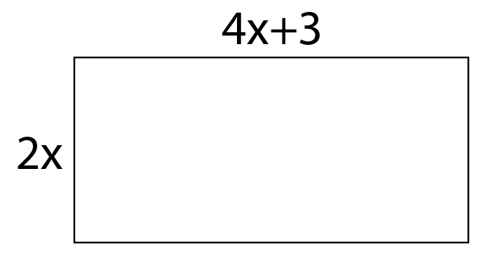

b. Write your expression in simplified form.

c. BONUS: If $x=5$, what is the perimeter of the rectangle?

