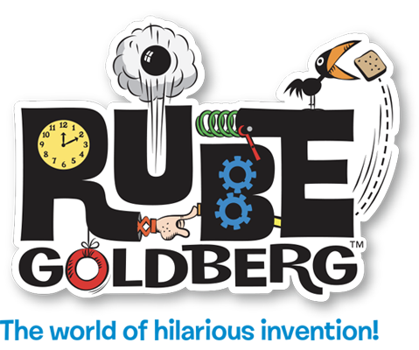
Rube Goldberg Bar of Soap Challenge - https://www.rubegoldberg.com/
Overview: Kids will create a Rube Goldberg Machine!
Families will work to complete the appropriate number of energy transfers to complete Rube Goldberg Machine that drops a bar of soap in a person’s hand. Through this design challenge, students and their family members will act as engineers, artists and designers, creating simple machine and engineering concepts while using their artistic capabilities.

ACTIVITY

Who are engineers? Engineers are people who use their creativity and knowledge of math and science to design things that solve problems. Today, you’ll be an engineer, using the Engineering Design Process to create a chain reaction contraption that drops a bar of soap into a person’s hand.

Materials (anything in your home, a list included here for inspiration only):
Paper towel holders, tape, pizza boxes, takeout containers, any type of cardboard, balls of different sizes and weights (an apple covered in aluminum foil can make a nice round ball!), dominoes or blocks, marbles, cups of various sizes, pulleys, match box cars, chairs, tables, foot stools, boxes.

Make sure to explore the Action/Mechanism/Symbol described below before starting your design.

This link will display a picture of simple machines you can create. Take a look to get some ideas on what you can create from materials in your home.

Let’s use an Engineering Design Process to solve this problem – build a chain reaction contraption that drops a bar of soap into the hands of a person after several steps (energy transfers).

The Engineering Design Process is:
- to ask questions about the problem,
- imagine ways to solve it,
- plan a design,
- create and test it,
and then think about ways to improve it.

Let’s Begin:

- It is time to look at your materials and imagine different ways to make them work.
- Ask: Can you imagine any ways you could use these materials to engineer energy transfers?
- Plan out your steps on paper first to organize your design, gather your supplies, create and test your design model and then think about ways to improve it.
- If your design doesn’t work the first time, think about changing it or changing the materials you’ve selected.

Grades 6-8, the machine should have at least 5 steps but challenge yourself to 8 steps. Students make a video of their machine completing the task to share.

To see some examples, check out the video links provided below.

While watching the following videos in slow motion, families can document the actions and mechanisms they observe. If students cannot access these videos, please see the picture below as an example:

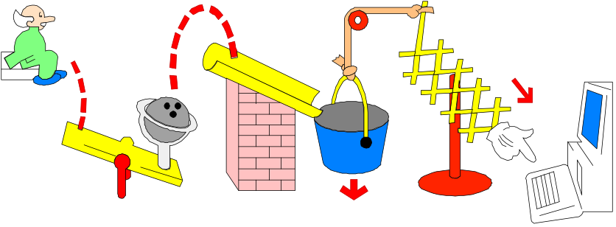

- Once they have identified materials they can use, families should consider drawing out their plan to complete the design challenge.
- Families create and test their machines! If you can, try documenting the process by making a video of their machine going through the various steps to from start to finish, ending with completing the task of dropping a bar of soap in a person’s hand.

For more family fun, compete in the international RUBE GOLDBERG BAR OF SOAP VIDEO CHALLENGE! Build a working 10 to 20-step Rube Goldberg Machine that drops a bar of soap into someone’s hands, film it and introduce your team, upload the video to YouTube and send the link to: rubefamilychallenge@rubegoldberg.com

Click here for details. You can also post to social media tagging @NYCSchools & using #NYCSTEM and #rubetotherescue2020 on Twitter or Instagram.

General Videos for inspiration:
  - Audri’s Monster Trap
  - Ok Go, This Too Shall Pass by OK Go and Syyn Labs:
  - Isaac Newton vs Rube Goldberg by 2D House & How it was filmed
  - All In Against Aids Campaign by 2D House.
  - The Pizza Delivery Machine, Sprice Machines
  - Paper Plane Trickshot Machine by Sprice Machines & How it’s filmed
For more structure, use our list of verbs (action words) to predict what kind of movement each action makes. As you test your builds, establish new ways of describing the motions and steps that makes sense to everyone. Going forward in our conversations we will call these actions.
As a family, come up with a general list of things that perform actions, based on common knowledge. In second column are mechanisms. Mechanisms have simple machines in them. Actions are the verbs, mechanisms are how they are used.

Making Connections: Write down the actions and mechanisms you observe.
Then draw lines connecting which mechanisms perform which actions.

Action / Mechanism / Symbol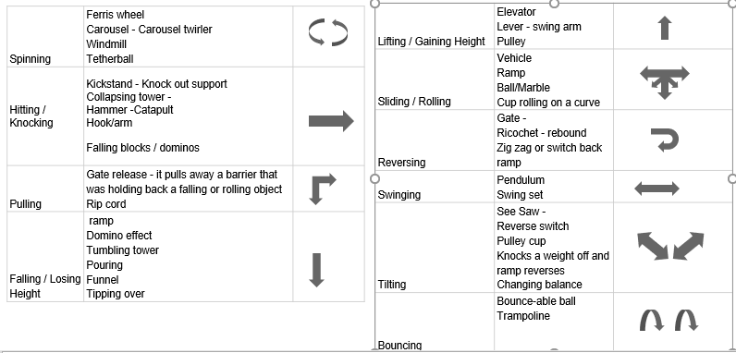
Building mechanisms: observe examples, then individually create samples of each mechanism
Create contraptions: Using the mechanisms you’ve created, assemble action sequences.
Actions and Mechanisms: The basis for how we teach and talk about contraptions.

You have now created a common vocabulary for contraption-building! Now you’re ready to build.

History: Rube Goldberg was a cartoonist and early design innovator who lived in New York City during the Industrial Revolution; the fast-paced changes in the city around him inspired his famous wacky contraption cartoons. His legacy includes about 50,000 cartoons, games such as Mousetrap, books, and toys.

