MS 890 8th Grade Summer Reading Assignment

Students!

Happy Summer! Summer is a time to relax and recharge. At the same time, you will want to do some reading and math, so that your skills will remain strong.

This summer you must select - and read - two of the books from the NYC Reads 365 list. LINK IS IN THE GOOGLE CLASSROOM ASSIGNMENT TOO. After reading, complete the following:

- Assignment 1: “One Pager” assignment for one book (there are templates and example of the assignment attached)

AND
- Assignment 2: Book report for the second book (format attached)

Please bring the completed assignments with you on the first day of school, or, submit the assignment electronically through our google classroom.

See you in September!

Mr. Freeman

Recommended Pacing Calendar
- June 28 - July 5th RELAX
- July 6th - Select one book. Read approx. 15-20 min a day
- July 18th - Begin your first “One Pager” assignment. Work approx. 20 minutes a day
- July 22nd - Complete first assignment
- July 23rd to July 31st! Break! During this time, I recommend that you continue reading your independently selected novel for your own enjoyment. Set a goal of 20 minutes a day
- Aug. 1st - Begin your second novel. Read approx. 20 min per day
- Aug. 22nd - Begin your second assignment (Book Report). Write approx. 20 minutes per day so that you will have your assignment completed by Friday, Aug. 26th
- Aug. 29th - to the first day of school. Read independently selected novels for 15 – 20 minutes per day to continue increasing your pace. Set a timer for 15 minutes and focus strictly on the novel with no interruptions (no cell phones, etc.). Try to do this each day, and track your speed / number of pages per minute.

One Pager Directions:

A one pager is a way to visually share key ideas and information from what you have learned as you’ve read a novel. When you create a one pager, you are trying to use both visual symbols and important words to clearly and concisely share important takeaways with someone else.
TEMPLATES PROVIDED.
TEMPLATE 1 MUST INCLUDE:
- A border which represents the key themes from what you have read
- An image in the upper left hand corner with a quotation woven into or around it. This image should somehow represent what you consider to be the most important symbol in the text
- Images and/or doodled words in the upper right hand corner that represent the key characters from the text and perhaps how they changed
- Images and quotations in the lower left hand corner that show the author’s style of writing, and the power of language that is used
- Images and/or words in the bottom right hand corner that show connections between the themes and ideas in the writing and what is going on in the world today
- Three important quotations from the text
- Words and/or images that show the significance of the setting in some way

*** YOU CAN USE THE TEMPLATE ONE FROM GOOGLE CLASSROOM, OR THE HANDOUT.***
TEMPLATE 2 MUST INCLUDE:
- A border that represents the key characters from the reading through words and or/images
- A look at the author’s style in the upper left hand corner, including some short quotations
- An image or set of images in the upper right hand corner that represent an important symbol in the book
- Images and words across the middle that represent the key themes of the book
- The bottom section should show images and words that connect the text to other texts, movies, history, or modern day life. Must include at least three quotations.
You may add other symbols, drawings, and words that represent the reading as you wish for either template.
*** YOU CAN USE THE TEMPLATE ONE FROM GOOGLE CLASSROOM, OR THE HANDOUT.***

Book Report Directions
Your book report should be broken down into the seven sections as follows. Use specific details from the text to support each answer.
1. Identify the SETTING of your novel, then explain why the setting is important. For example, if the story is set in 1977 in Afghanistan, why is this significant? If the book is set in contemporary times in the United States, what does that contribute to the overall meaning of the novel? Give examples from the book to back up what you say.

2. Discuss the CHARACTERIZATION in your novel. Begin with the protagonist. Is the character well-developed, or is s/he a stock or stereotypical character? Is the character static (unchanging throughout the story) or dynamic (changes by the end of the novel)? What personality traits does the character possess, and how does this affect the outcome of the novel? Then move on to the minor characters in the novel. Do the character's inner thoughts and feelings reflect his/her outward actions? Explain. Give examples from the book to back up your point of view.
3. What is the POINT OF VIEW of the novel? First person, second person, third person? Why is this significant? For example, if the novel is told in first person, what advantages does this have? Why? Why do you think the author chose this point of view? Give examples from the book to back up what you say.
4. What is the CONFLICT in the novel? Is it character vs. character, character vs. nature, character vs. society, or character vs. him/herself? For this one, you will have to analyze the conflict much more deeply than you have in the past. Explain the conflict and how the protagonist deals with it. Does the protagonist overcome the conflict? Give evidence from the novel to support your view. There may be more than one conflict in the novel.
5. What is the THEME of the novel? Explore this deeply by asking yourself the question: What was the author's purpose in writing the book? Do NOT use stock themes such as "Don't judge a book by its cover." Make sure the themes reflect the specific meaning of THIS book.
6. What are the SYMBOLS in the novel? Why are they significant? How do they help develop the story and contribute to the overall meaning of the book? Give examples from the book to back up what you say.
7. Evaluate the ENDING of your novel. Was the ending justified? Was it believable? Was it a satisfactory ending? Did it fit the rest of the novel?

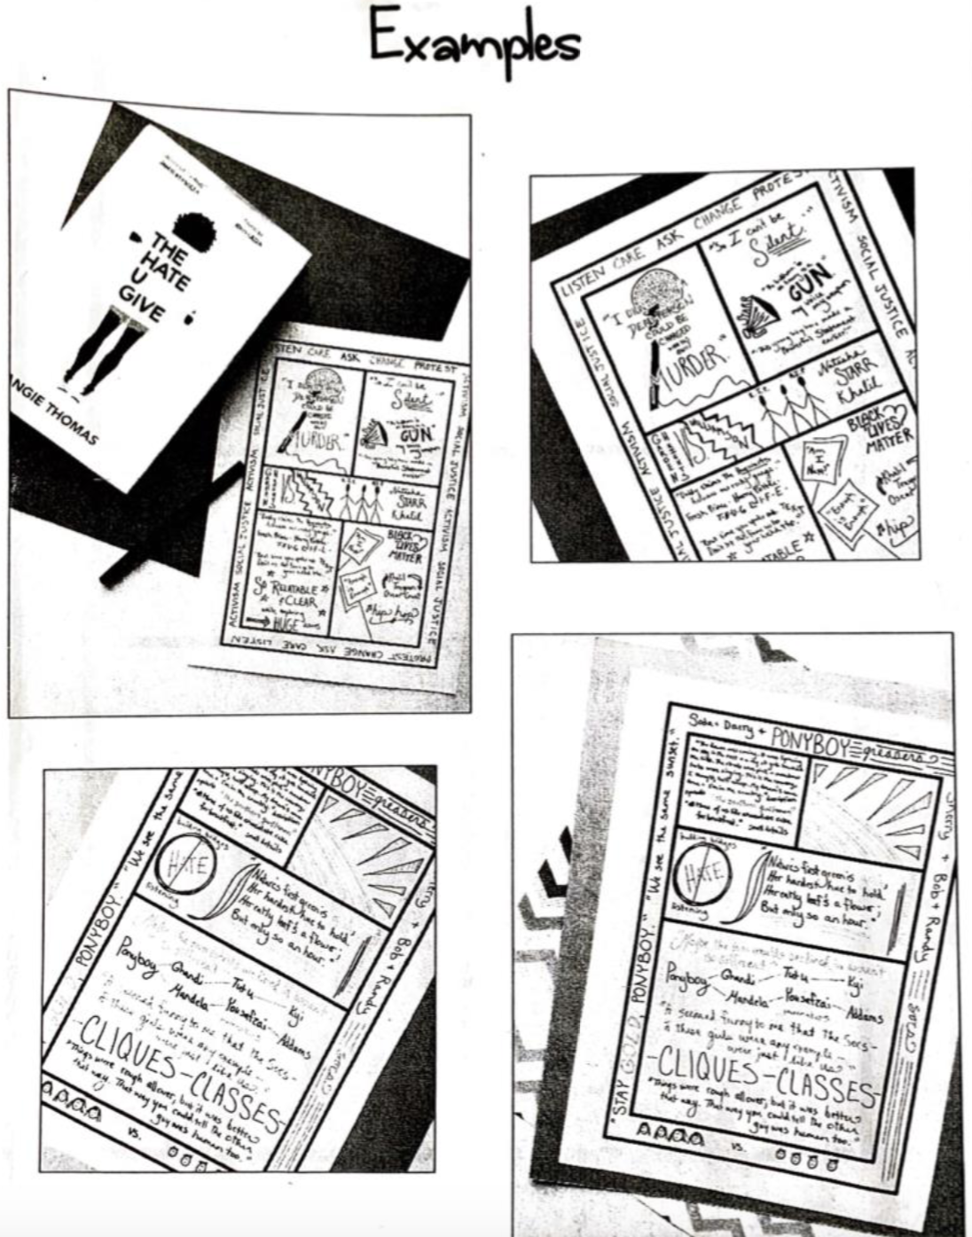

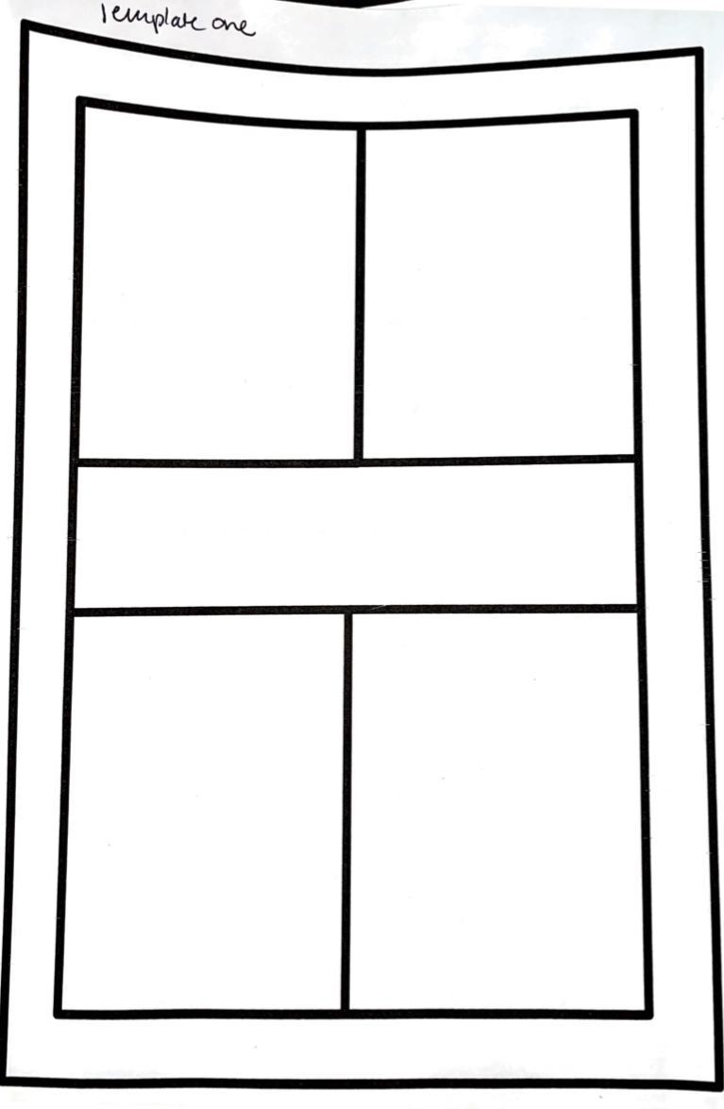
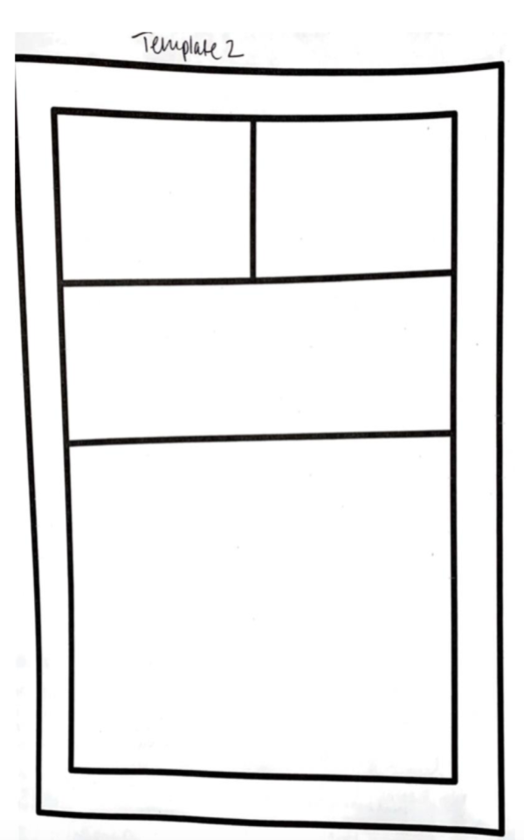
COMPLETE YOUR BOOK REPORT ON LOOSELEAF PAPER, OR THE DOCUMENT PROVIDED IN GOOGLE CLASSROOM.

