Grade 8

Mathematics
Quarter 2 2019 Benchmark Exam

Name: __________________________________________

Class: _________________

Directions:

- Read each question carefully. SHOW ALL OF YOUR WORK.

- For multiple-choice questions, you must mark your answers on the exam paper and on your answer sheet by darkening the circle for the letter that matches your answer choice.

- For written-response questions, you must write your answers and show of work clearly and legibly in the space provided.

Part One: Multiple Choice

_____ /20

Part Two: Short Response

_____ /6

Total Score

_____ /26
Part I: Multiple Choice

1. Visible light has a wavelength of about 0.0000475 cm. Which of the following represents the wavelength of visible blue light in scientific notation?
A. $4.75×{10}^{5}$
B. $475×{10}^{7}$
C. $4.75×{10}^{-5}$
D. $475×{10}^{-7}$

2. Which of the following is not equivalent to $\frac{1}{2^{3}}$?
A. $(2^{-5})(2^{2})$
B. $\frac{2^{17}}{2^{20}}$
C. $(2^{-2})(2^{5})$
D. $2^{-2}÷2^{1}$

3. What is the solution to the equation below?

$4\left(x-3\right)=\frac{1}{2}(10x+2)$

A. $13$
B. $12$
C. $-13$
D. $-1$

4. What is the solution to the equation below?

$2\left(x-3\right)=2x+5$

A. $x=2.75$
B. $x=-2.75$
C. There is no solution.
D. There are infinitely many solutions.

5. A line contains the points (4, 2) and (0, 1). What is the equation of the line?

A. $y=2x-6$
B. $y=\frac{3}{4}x-1$
C. $y=\frac{1}{4}x+1$
D. $y=\frac{4}{3}x-\frac{10}{3}$
6. What is the slope of the equation $y=4-\frac{1}{3}x$?

A. $4$
B. $-4$
C. $-\frac{1}{3}$
D. $\frac{1}{3}$

7. Which equation represents the line shown on the coordinate grid below?
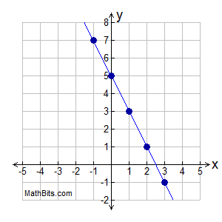
A. $y=2x+5$
B. $y=\frac{1}{2}x-5$
C. $y=-2x+5$
D. $y=-\frac{1}{2}x-5$

8. Kevin and Christy both saved money for their class trip. Kevin saved the same amount each week. The total amount that Kevin saved at the end of every two weeks is shown in the table below.

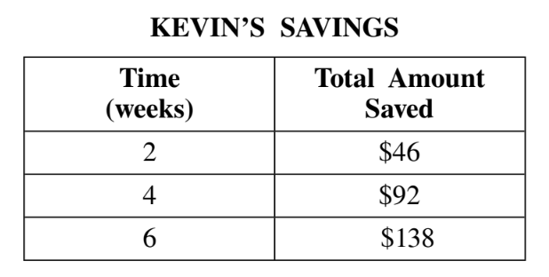

Christy’s savings can be modeled by the equation $y=26x$, where $y$ is the total amount of money saved in $x$ weeks. Which statement correctly compares the rates at which Kevin and Christy saved money?

A. Christy saved $3 per week more than Kevin.
B. Kevin saved $10 per week more than Christy.
C. Christy saved $18 per week more than Kevin.
D. Kevin saved $20 per week more than Christy.
9. What is the solution to the system of equations below?

$2x+3y=6$
$x-3y=9$

A. $\left(-1,\frac{8}{3}\right)$
B. $(-3, -4)$
C. $\left(5, -\frac{4}{3}\right)$
D. $\left(8, -\frac{1}{3}\right)$

10. The graph of a system of linear equations is shown below.

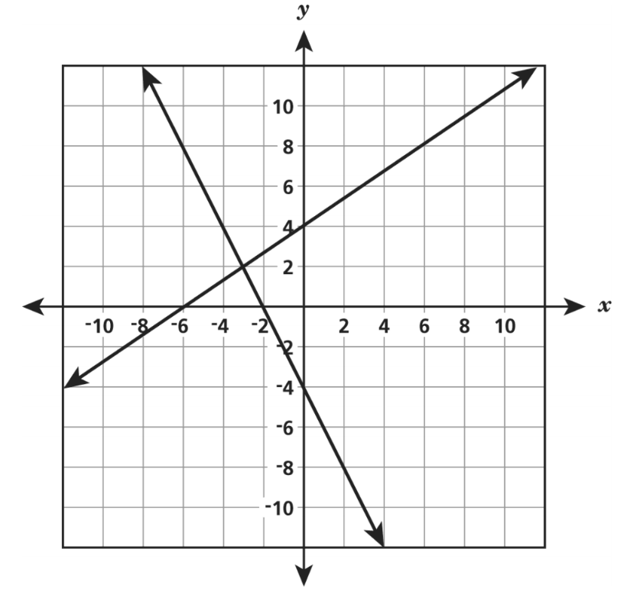

Which ordered pair is the best estimate for the solution of this system of linear equations?

A. $\left(-6,-2\right)$
B. $(-3, 2)$
C. $(4,-4)$
D. $(6, 8)$
Part II: Short Response

1. Graph and label the given system of equations on the coordinate grid shown below.
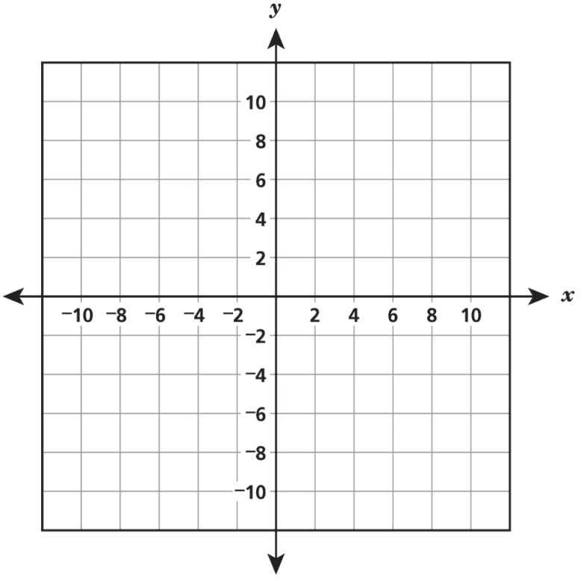
$y=\frac{1}{2}x+2$
$y=x-1$

What is the solution to the system of equations?

2. Charles needs to fill a large fish tank with water using a hose. He has two hoses from which to choose. Water flows through each hose at a constant rate. The graph below shows the amount of water, in gallons, that flows through Hose A based on the number of minutes used.

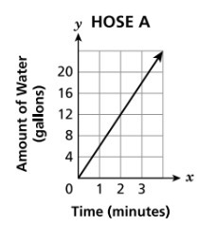

A total of 112 gallons of water can flow through Hose B in 14 minutes. Which hose has a faster water flow rate, in gallons per minute, and what is that rate?

