Grade 8/Algebra I

Mathematics
2019 Benchmark 2 Exam

Name: __________________________________________

Class: _________________

Directions:

- Read each question carefully. SHOW ALL OF YOUR WORK.

- For multiple-choice questions, you must mark your answers on the exam paper and on your answer sheet by darkening the circle for the letter that matches your answer choice.

- For written-response questions, you must write your answers and show of work clearly and legibly in the space provided.

Part One: Multiple Choice

_____ /20

Part Two: Short Response

_____ /6

Total Score

_____ /26
Part I

1. Visible light has a wavelength of about 0.0000475 cm. Which of the following represents the wavelength of visible blue light in scientific notation?

A. $4.75×{10}^{5}$
B. $475×{10}^{7}$
C. $4.75×{10}^{-5}$
D. $475×{10}^{-7}$

2. What is the solution for the following system of equations?

$$2x+y=7$$
$$x-2y=6$$
A. (3,1)
B. (1,3)
C. (-1,4)
D. (4,-1)

3. What is the value of x in the equation $\frac{3}{4}x+2=\frac{5}{4}x-6$?

A. -16
B. 16
C. -4
D. 4

4. What is the solution to the equation below?

$$2\left(x-3\right)=2x+5$$

A. $x=2.75$
B. $x=-2.75$
C. There is no solution.
D. There are infinitely many solutions.

5. A line contains the points (4, 2) and (0, 1). What is the equation of the line?

A. $y=2x-6$
B. $y=\frac{3}{4}x-1$
C. $y=\frac{1}{4}x+1$
D. $y=\frac{4}{3}x-\frac{10}{3}$

6. What is the value of x in the equation $13x-2\left(x+4\right)=8x+1$?

A. 1
B. 2
C. 3
D. 4

7. Which equation is equivalent to $x+2y=6$?

A. $y=-x+6$
B. $y=-\frac{1}{2}x-6$
C. $y=-x+3$
D. $y=-\frac{1}{2}x+3$

8. Which of the following is not equivalent to $\frac{1}{2^{3}}$?

A. $(2^{-5})(2^{2})$
B. $\frac{2^{17}}{2^{20}}$
C. $(2^{-2})(2^{5})$
D. $2^{-2}÷2^{1}$

9. Which statement is true about the graph of the line whose equation is $y=8$?

A. The line is parallel to the x-axis.
B. The line is parallel to the y-axis.
C. The line passes through the origin.
D. The line has a slope of 8.

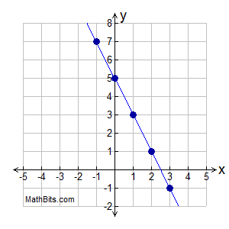
10. Which equation represents the line shown on the coordinate grid to the right?

A. $y=2x+5$
B. $y=\frac{1}{2}x-5$
C. $y=-2x+5$
D. $y=-\frac{1}{2}x-5$

11. If the slope of a straight line is 0, the graph of this line may pass through Quadrants

A. I and II
B. I and III
C. I and IV
D. II and IV

12. Which ordered pair is the solution set of the following system of inequalities?

$$y<\frac{1}{2}x+4$$
$$y≥-x+1$$
A. (-5,3)
B. (0,4)
C. (3,-5)
D. (4,0)

13. When solved graphically, which system of equations will have exactly on point of intersection?

A. $y=-x-20$
$$y=x+17$$

B. $y=0.5x+30$
$$y=0.5x-30$$

C. $y=\frac{3}{5}x+12$
$$y=0.6x-19$$

D. $y=-x+15$
$$y=-x+25$$

14. Which ordered pair is in the solution set of the system of inequalities shown in the accompanying graph?
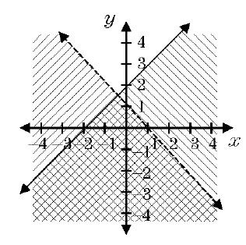
A. (2,5)
B. (2,-2)
C. (4,3)
D. (-4,3)

15. What is the value of x in the equations $\frac{3}{4}x+2=\frac{5}{4}x-6$?

A. -16
B. 16
C. -4
D. 4

16. One the coordinate plane below, rectangle ABCD is rotated 90º clockwise about the origin to form rectangle WXYZ.
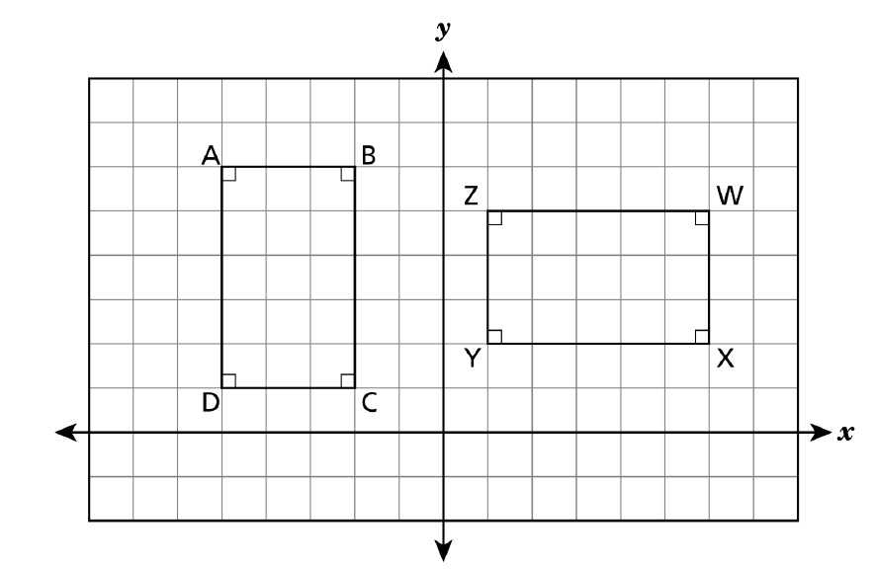

Which statement about the relationship between rectangle ABCD and rectangle WXYZ is true?

A. $\overline{DA}≅\overline{YZ}$
B. $\overline{DC}≅\overline{XY}$
C. $\overline{BC}≅\overline{YZ}$
D. $\overline{AB}≅\overline{WX}$

Part II

15. On the set of axes below, solve the following system of equations graphically. State the coordinates of the solution.

$$y=4x-1$$
$$2x+y=5$$

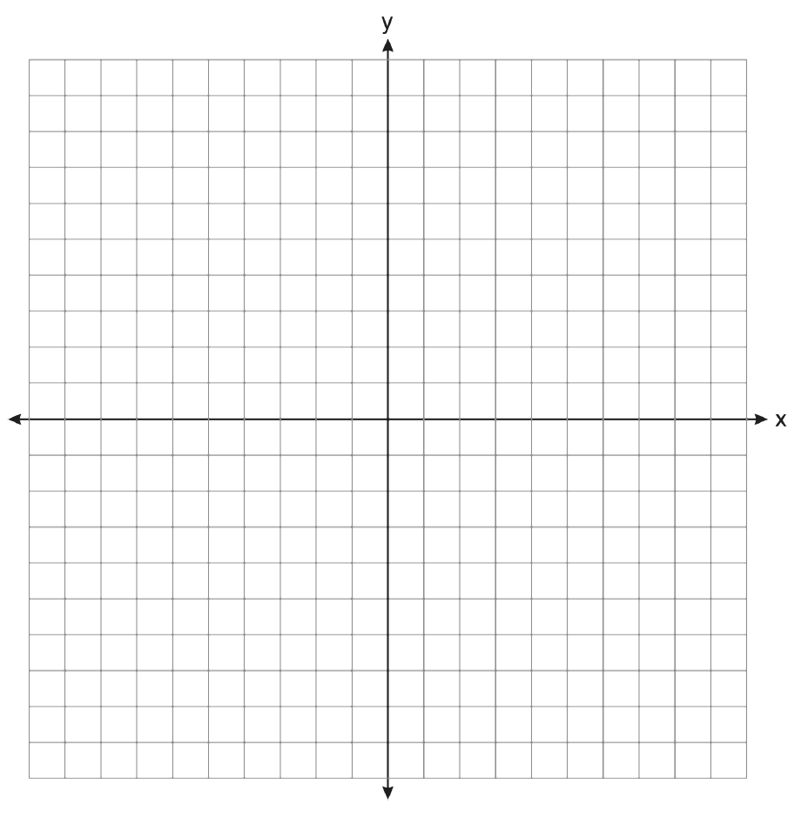

16. Graph the following system of inequalities on the set of axes shown below and label the solution set S.

$$y>-x+2$$
$$y≤2x+5$$

17. Charles needs to fill a large fish tank with water using a hose. He has two hoses from which to choose. Water flows through each hose at a constant rate. The graph below shows the amount of water, in gallons, that flows through Hose A based on the number of minutes used.
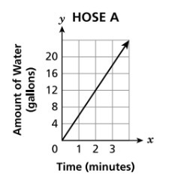

A total of 112 gallons of water can flow through Hose B in 14 minutes. Which hose has a faster water flow rate, in gallons per minute, and what is that rate?

