Name ______________________________________________________________________________________
Unit One Homework #4
Unit 1 | Date Assigned: | Due Date:
Assignments |  |  | Self-Assessment | Points Earned
- Operation and Real World Problems  - Complete the problems in the attached assignment.  - If you need more space use looseleaf |  |  | - I did excellent!  - I did well.  - I did okay  - I am having trouble understanding.
- Order of Operations  - Complete the problems in the attached assignment.  - If you need more space use looseleaf |  |  | - I did excellent!  - I did well.  - I did okay  - I am having trouble understanding.
Total

Operations and Real World Problems
Find the solution to the following problems. Please show all work. Write final answer in a complete sentence.
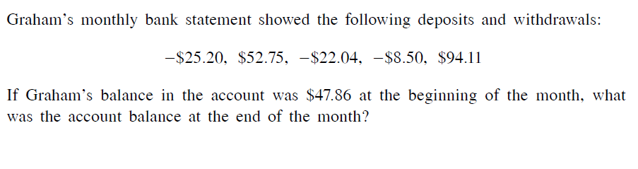
1.

2.

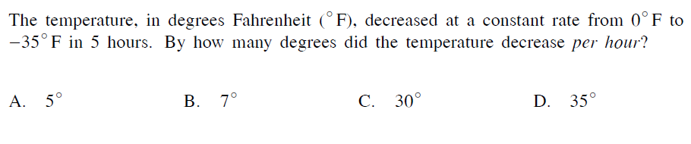
3.

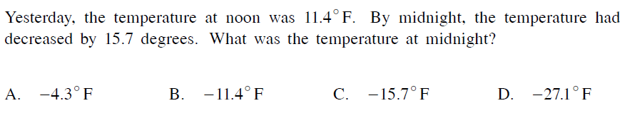
4.

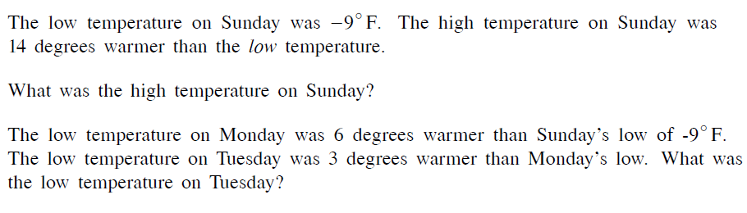
5.

6.

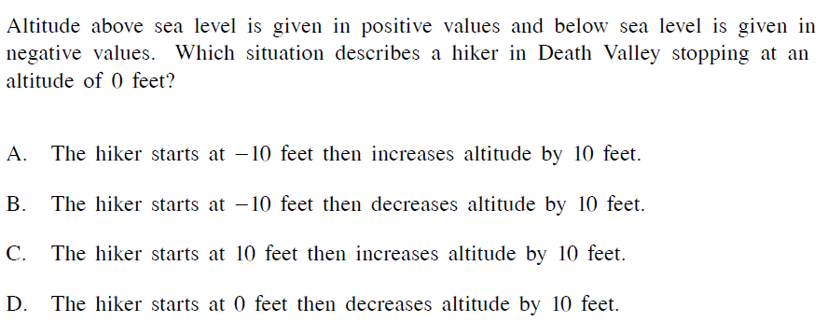
7.

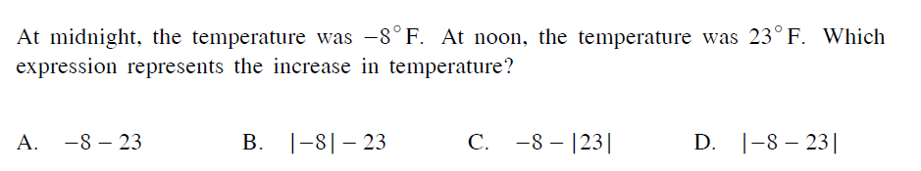
8.

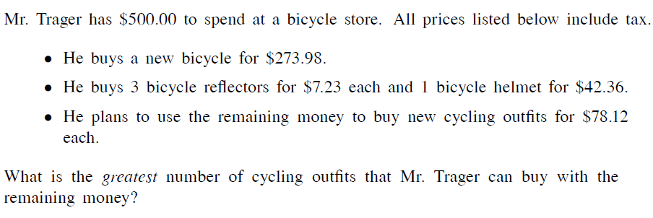
9.

10.

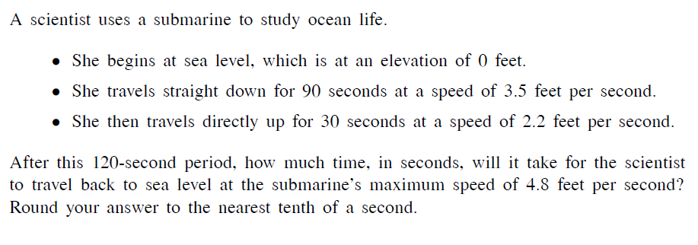
11.

Order of Operations
Find the solution to the following problems. Please show all work.
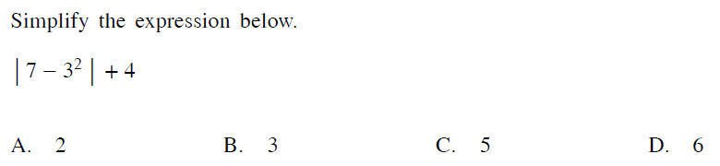
12.

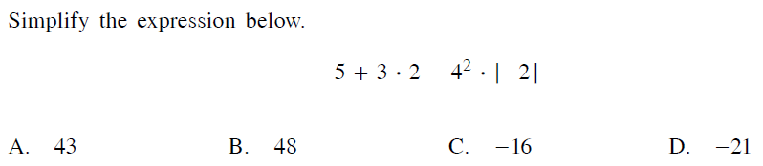
13.

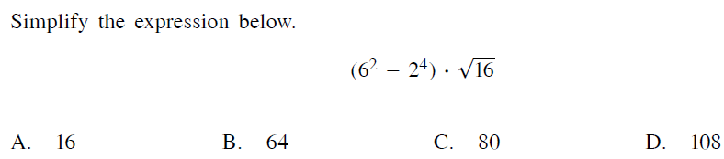
14.

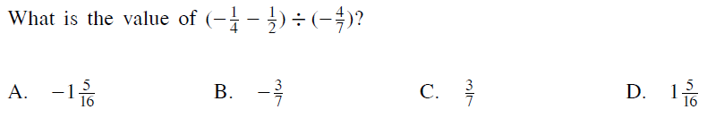
15.

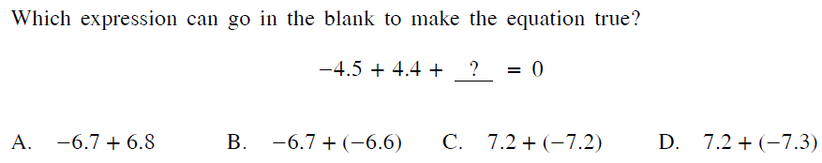
16.

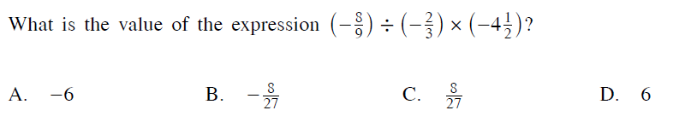
17.

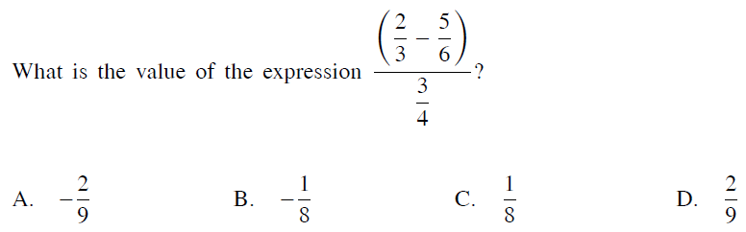
18.

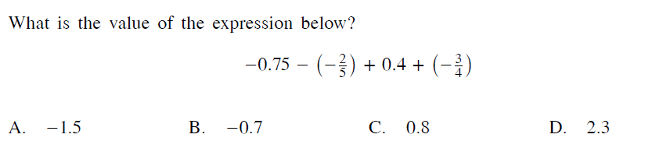
19.

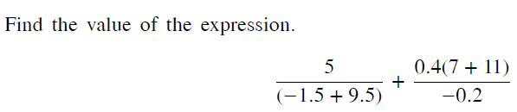
20.

